How to create a RedShift Cluster

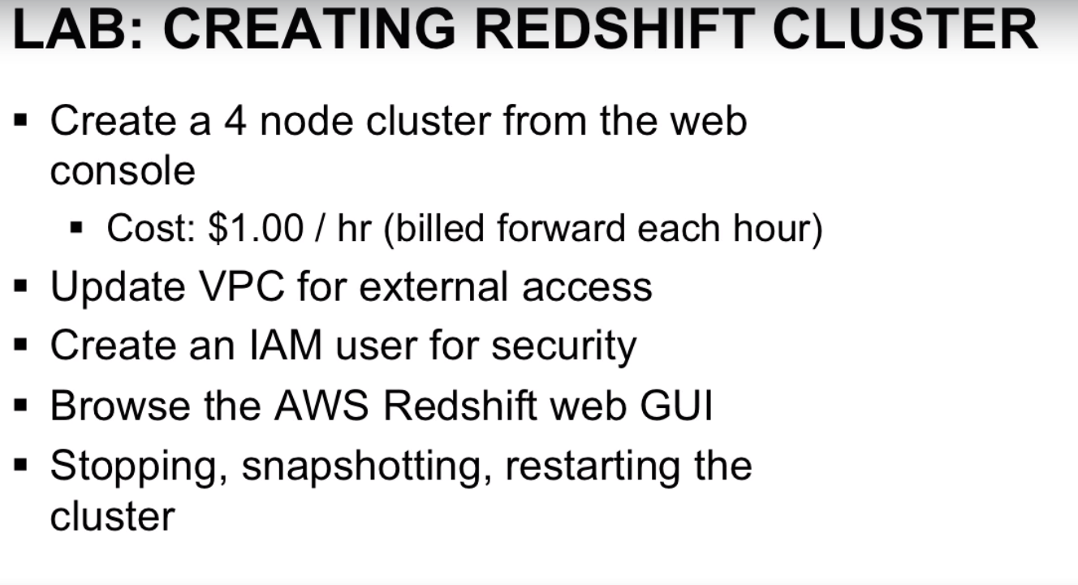

Step1- **Login into your Amazon AWS account**

Step 2- Go to Services and select **“RedShift”**

Step3- Click on Launch Cluster and fill in the options as shown in the Images 3.1 and 3.2 below:

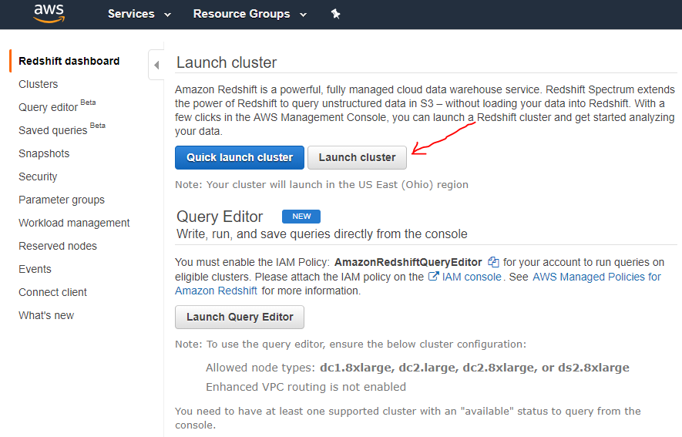

**IMG 3.1**

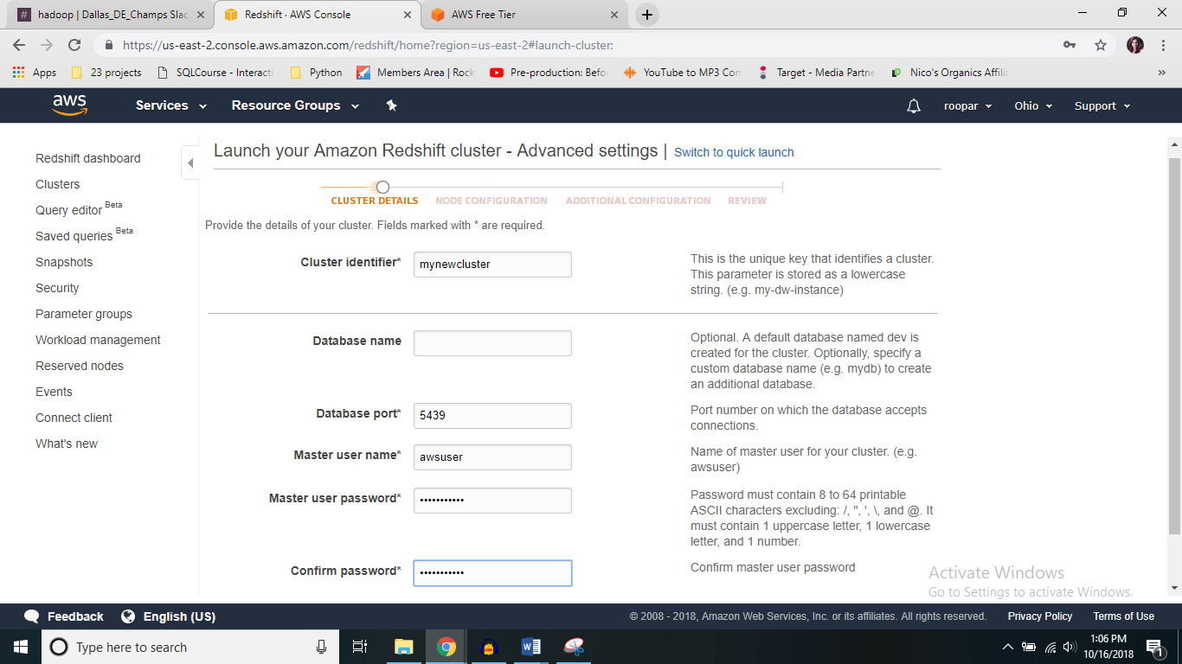

**IMG 3.2**

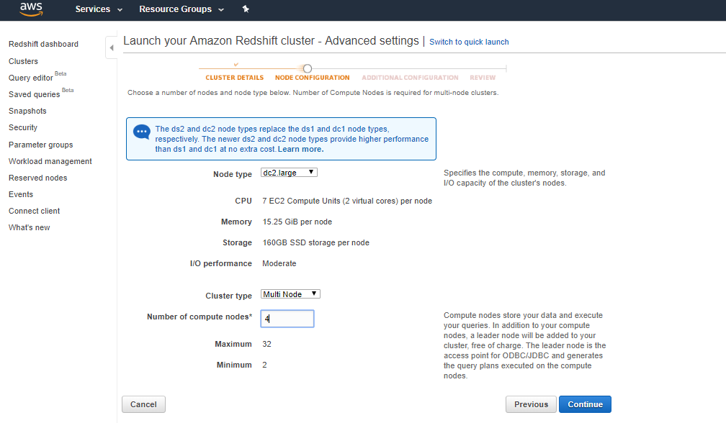

**IMG 3.3**

After you have filled in the fields with options, please click “**continue**”, you would get a screen like this, make the selections as shown in IMG 3.4

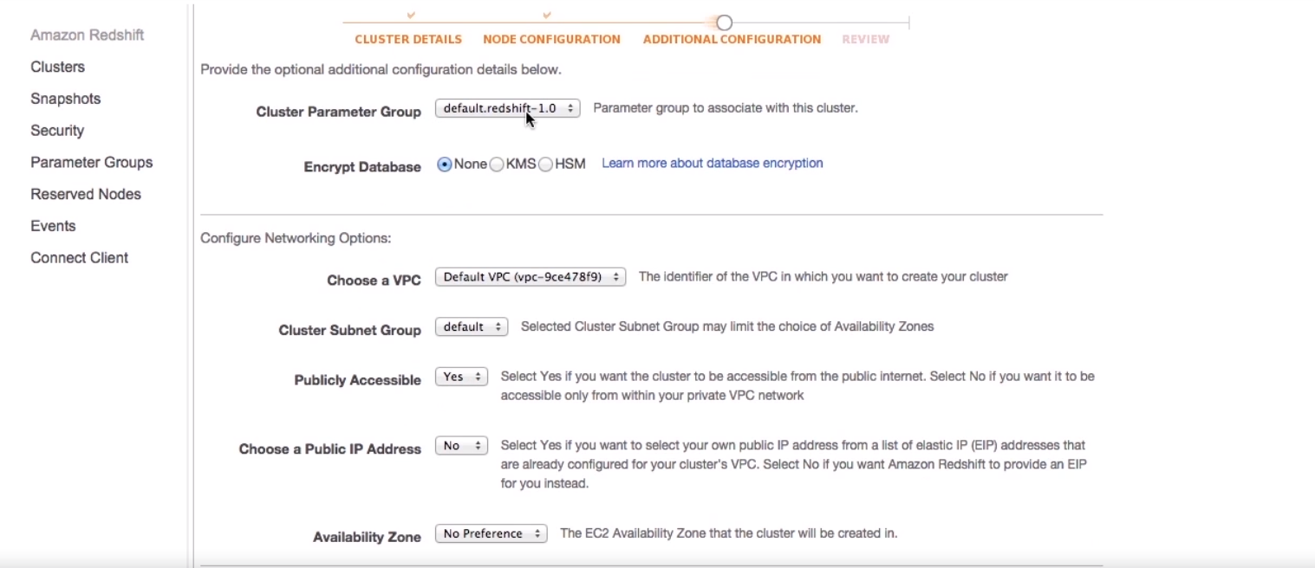

**IMG 3.4**

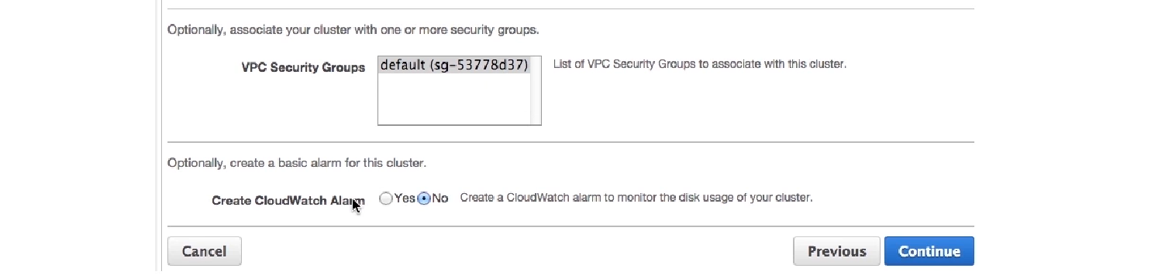

**IMG 3.5**

Before selecting “continue”, make sure you have filled in your options properly following IMG 3.1 - IMG 3.5

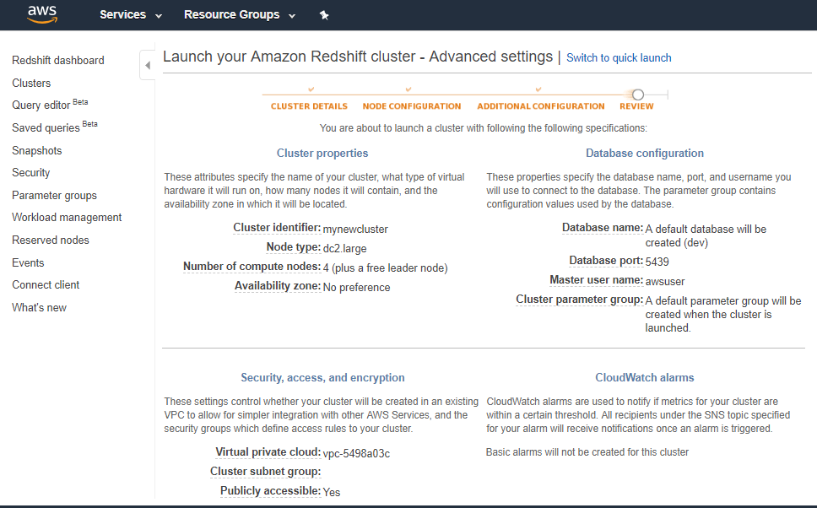

**IMG 3.6**

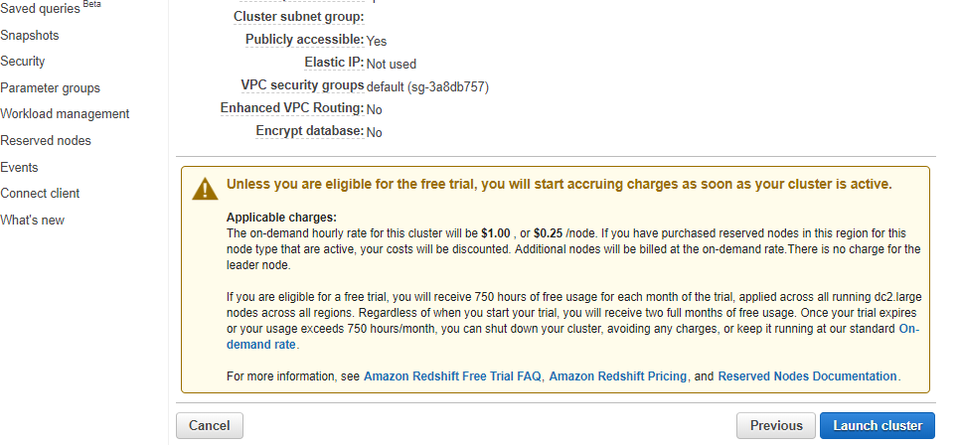

**IMG 3.7**

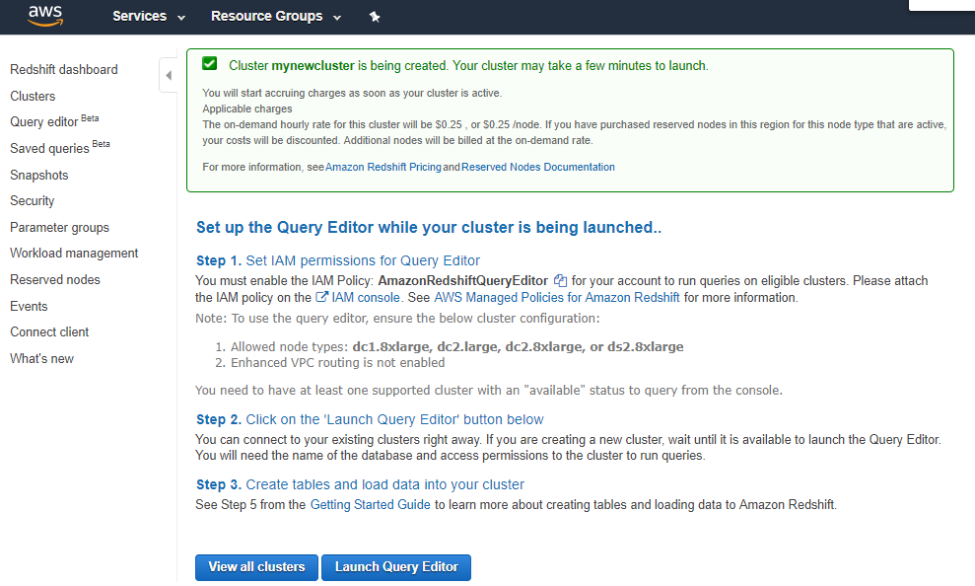

**IMG 3.8**

You have successfully launched your cluster, but you need to configure some more settings

Make sure you remember the region in which you have launched your AWS RedShift Cluster

It usually takes 2-5 minutes for a RedShift cluster to come to a Running state

Step4- **Configure VPC Security Groups**

* Open the AWS services in a new tab (keep the previous tab on Redshift cluster)
* Go to services and select “VPC” under Networking
* You should be able to see 1 VPC, click on “Security Groups” (it should be listed on the left side)
* There should be 1 security group present. Select and configure the settings as follows in IMG 4.1-

1. Select Inbound rules and click on edit
2. Click on “Add another Rule” and make the selections as follows
3. Click on save and you have successfully configured your security groups. Congratulations!

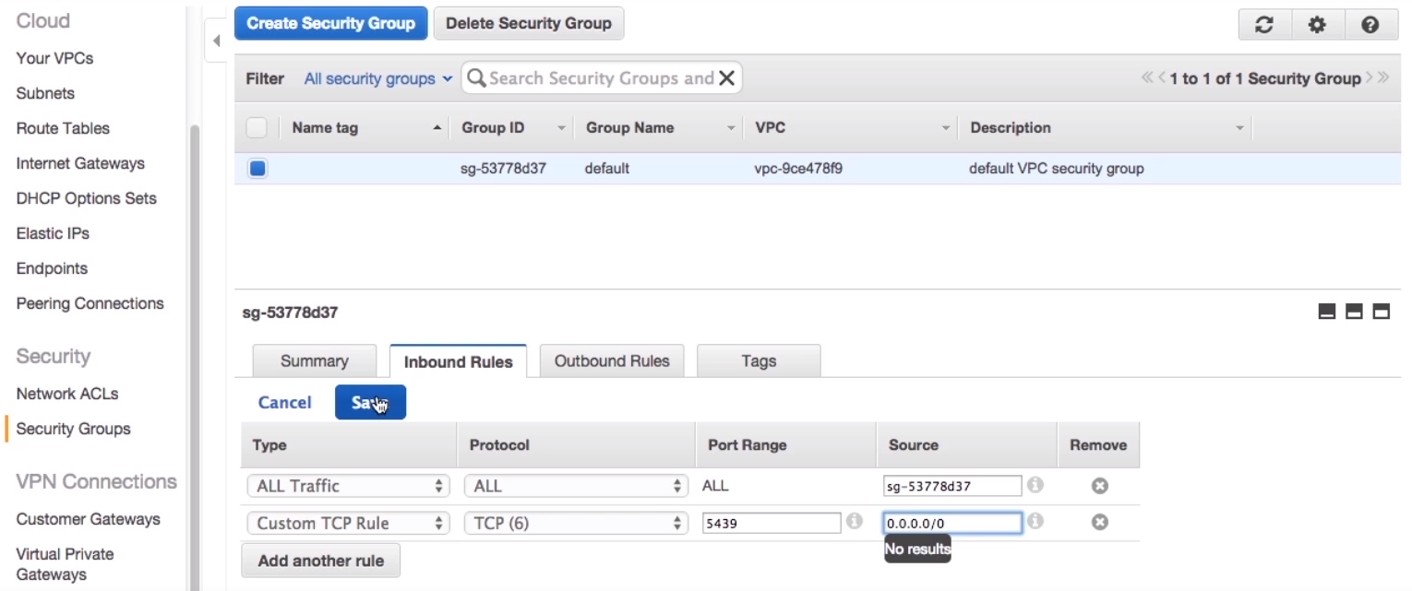

**IMG 4.1**

Step5- **Create an IAM user**

* Open the AWS services in a new tab and click on **“Identity and Access Management**” (you should be having two tabs already opened, Redshift cluster and VPC security group)
* Click on “**Users**” (listed on the left side) and Select “**Add User**” as shown in IMG 5.1 and IMG 5.2

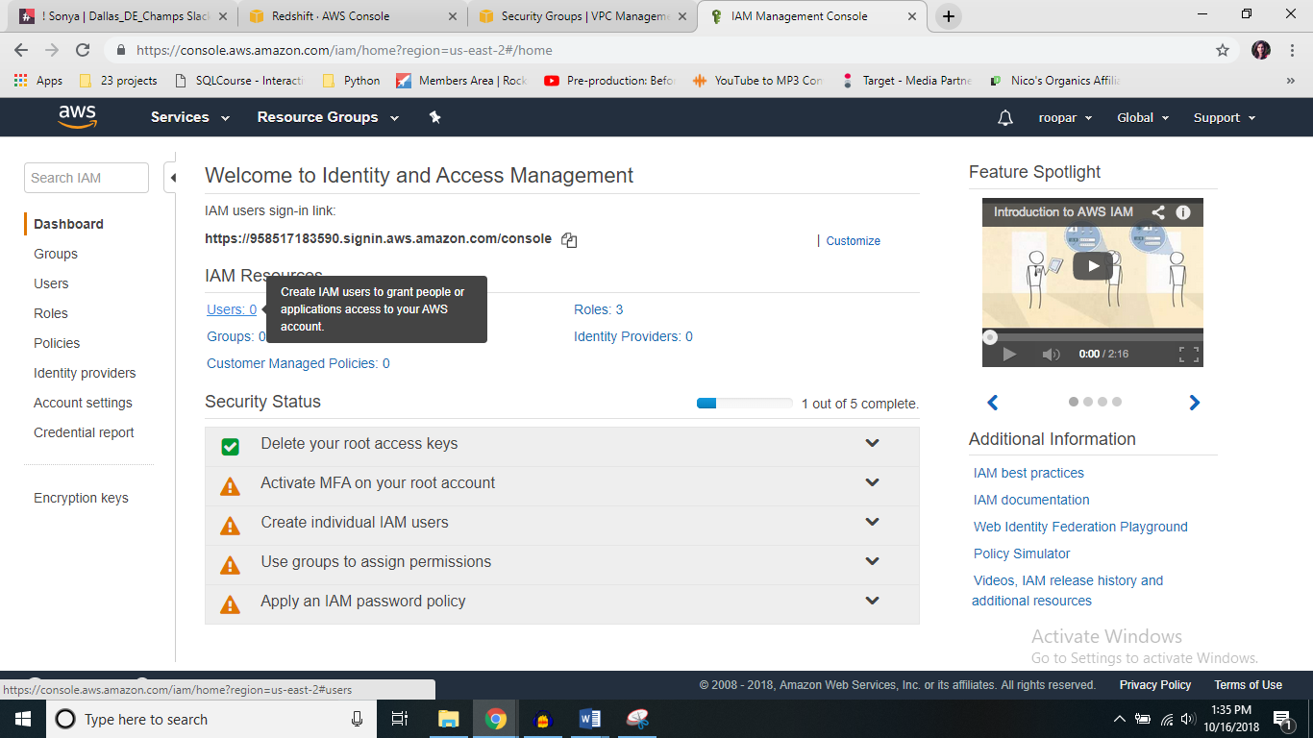

**IMG 5.1**

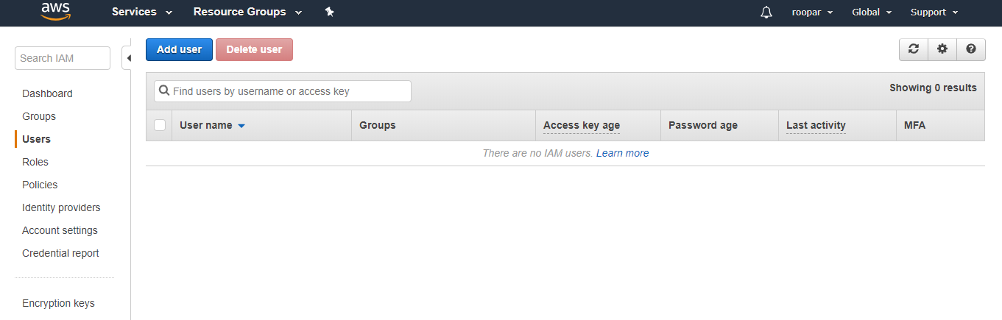

**IMG 5.2**

Step a: Set User details

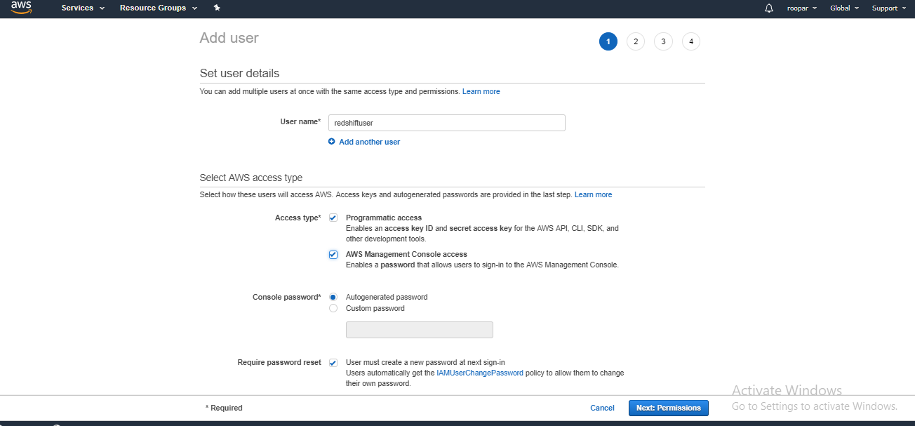

Step b: Set permissions

1. Search for “Redshift” in the search tab and select “**AmazonRedshiftFullAccess**” as shown

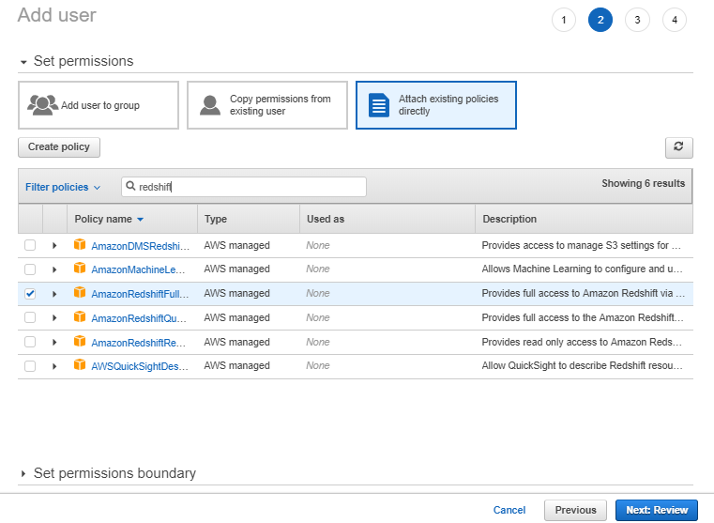

1. Search for S3 and select **AmazonS3fullaccess** policy

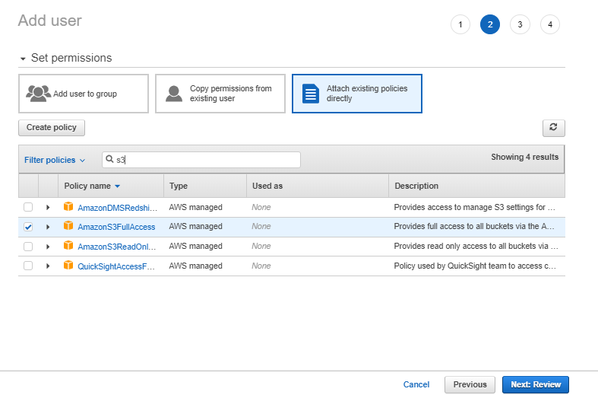

Step c: Review

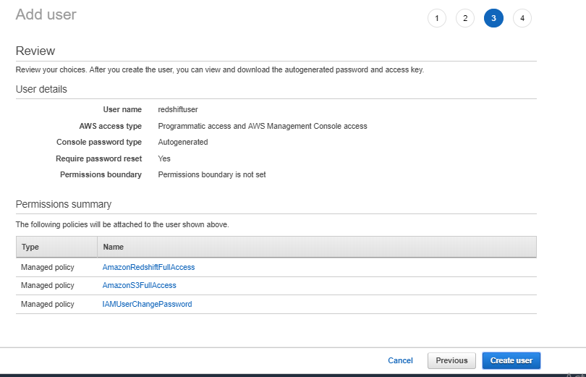

Step d: Add user – Success page

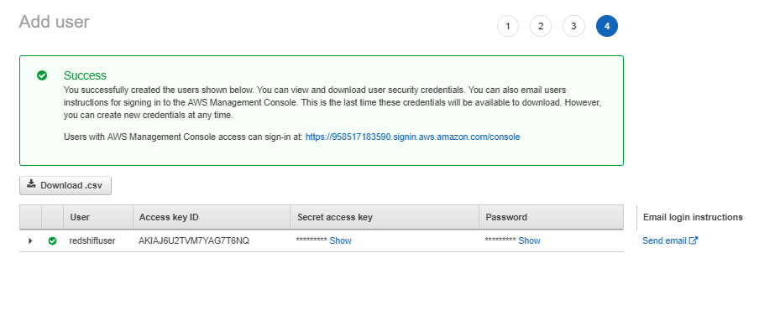

* Please click on the option “**Download.csv**”. This would appear at the top of the user name as shown above (Make sure you remember the path of the Credentials when you downloaded them, we would be needing them during our labs)

**Step6-**

* Come back to your AWS Redshift Cluster tab and refresh your page, your cluster should be healthy and running
* Click on the Cluster name, scroll down and you should be able to see **“Cluster Database Properties”,** Please copy the **“JDBC URL”** and save it in a file.

**Step7-** **Connect to a client**

* Come back to main page of “AWS RedShift” and click on “**Connect Client”** and follow the setting as shown in IMG 7.1

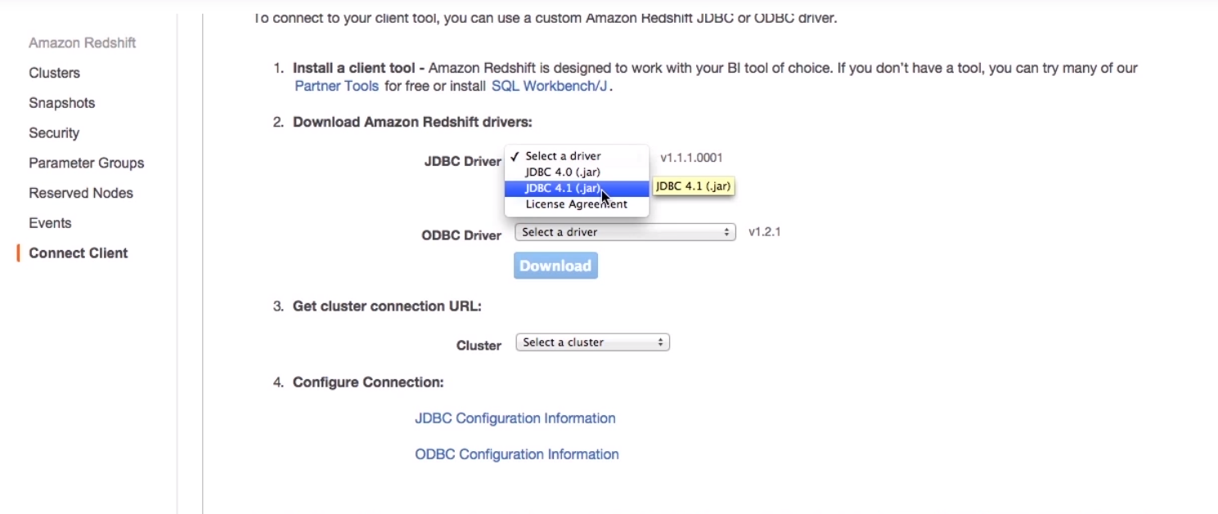

IMG 7.1

Make sure you remember the location of the jar file!

Please refer the following link for configuring your jdbc connection

<https://docs.aws.amazon.com/redshift/latest/mgmt/generating-iam-credentials-configure-jdbc-odbc.html>

**Congratulation! You have successful configured and launched your First RedShift Cluster**